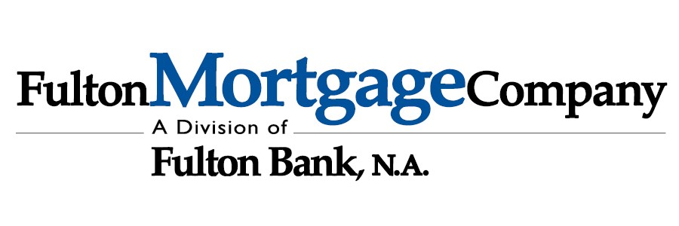
MEMBER FDIC

Mortgage Pre-Approval Checklist
Income
- Most Recent 2 pay stubs (for all jobs held)
- 2024 & 2025 W2s &/or 1099s (for all jobs held)
- 2024 & 2025Federal Tax Returns (depending on mortgage product)

Assets
- Latest 2 months of bank statements, all pages
- Latest 2 months of an additional assets, all pages (IRAs, 401Ks, TSPs, etc.) if needed

Other (if applicable)
- Copy of your diploma/ certification of completion of fellowship (if medical professional)
- Copy of your current medical license (if medical professional)
- DD-214 (if active military or veteran)
- Income Based Repayment Plan confirmation for student loans
- Divorce Decree &/or Separation Agreement (if ever divorced)
- Child Support & or Alimony Orders (if any paid or received)
- Copy of driver’s licenses

Please feel free to contact me if you have any questions about the items needed listed above.
Sincerely,
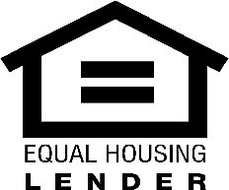
Jeffrey Vilk
Sr. Loan Officer
Vice President, NMLS #691636
JVilk@fultonmortgagecompany.com | 267-736-7962 1501 N Broad Street Phila PA, 19122

