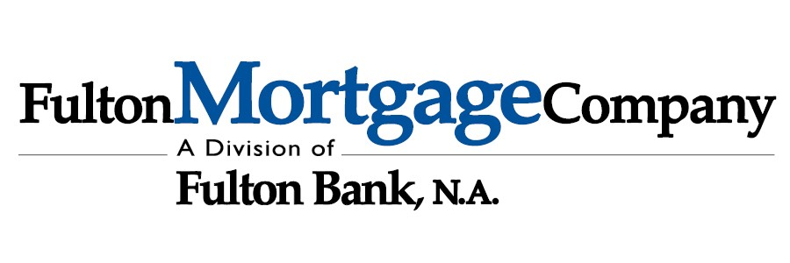
MEMBER FDIC

Mortgage Pre-Approval Checklist
Income
- Most Recent 2 pay stubs (for all jobs held)
- 2023 & 2024 W2s &/or 1099s (for all jobs held)
- 2024 Federal Tax Returns (depending on mortgage product)

Assets
- Latest 2 months of bank statements, all pages
- Latest 2 months of an additional assets, all pages (IRAs, 401Ks, TSPs, etc.) if needed

Other (if applicable)
- Copy of your diploma/ certification of completion of fellowship (if medical professional)
- Copy of your current medical license (if medical professional)
- DD-214 (if active military or veteran)
- Income Based Repayment Plan confirmation for student loans
- Divorce Decree &/or Separation Agreement (if ever divorced)
- Child Support & or Alimony Orders (if any paid or received)
- Copy of driver’s licenses

Real Estate (if any owned)
- Most recent Mortgage Statement for all homes owned
- Most recent Property Tax Bill for all homes owned
- Copy of private lien for primary residence
- Copy of most recent condo due statement
- Most recent Homeowner’s Declarations page for all homes owned

Please feel free to contact me if you have any questions about the items needed listed above.
Sincerely,
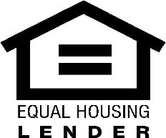
Jeffrey Vilk
Sr. Loan Officer
Vice President, NMLS #691636
JVilk@fultonmortgagecompany.com | 267-736-7962 1501 N Broad Street Phila PA, 19122

