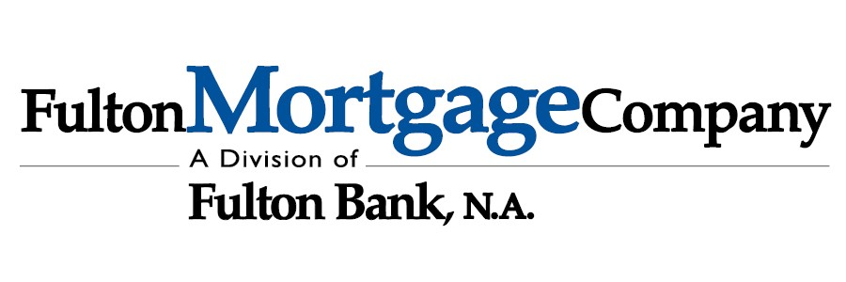
MEMBER FDIC

Mortgage Pre-Approval Checklist
Income
- Most Recent full month of pay stubs (for all jobs held)
- 2021 & 2022 W2s &/or 1099s (for all jobs held)
- 2021 and 2022 complete personal &/or business federal tax returns, all schedules included

Assets
- Latest 2 months of bank statements, all pages
- Latest 2 months of an additional assets, all pages (IRAs, 401Ks, TSPs, etc.)

Real Estate (if any owned)
- Most recent Mortgage Statement for all homes owned
- Most recent Property Tax Bill for all homes owned
- Copy of private lien for primary residence
- Copy of most recent condo due statement
- Contact for condo/HOA
- Most recent Homeowner’s Declarations page for all homes owned

Other (if applicable)
- Copy of your diploma/ certification of completion of fellowship (if medical professional)
- Copy of your current medical license (if medical professional)
- DD-214 (if active military or veteran)
- Income Based Repayment Plan confirmation for student loans
- Divorce Decree &/or Separation Agreement (if ever divorced)
- Child Support & or Alimony Orders (if any paid or received)
- Bankruptcy/ Foreclosure Documents (if filed in the past)
- Copy of driver’s licenses

Please feel free to contact me if you have any questions about the items needed listed above.
Sincerely,
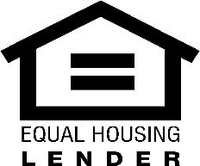
Jeffrey Vilk
Mortgage Sales Manager
Vice President, NMLS #691636
JVilk@fultonmortgagecompany.com | 267-736-7962 1501 N Broad Street Phila PA, 19122

